BUSINESS INTELLIGENCE LAB
UNIT 2 | SESSION 6
EXPERIMENT 6
Development of an Executive Dashboard and Business Performance Scorecard using Power BI
--------------------------------------------------------------------------------------------------------------------
1. AIM
To develop an interactive Executive Dashboard and Business Performance Scorecard using Microsoft Power BI to monitor key performance indicators, visualize business performance, compare actual results against predefined targets, and support data-driven decision-making.
2. OBJECTIVES
- To reuse the existing Power BI data model and dataset from Experiment 5.
- To create KPI measures for Total Sales, Total Profit, Total Orders, and Profit Margin (%).
- To develop an interactive Executive Dashboard using appropriate charts and KPI cards.
- To visualize sales by region, sales by category, monthly sales trends, top 10 customers by sales, and profit by segment.
- To implement interactive slicers for Region, Category, and Year.
- To develop a Business Scorecard comparing actual performance with predefined targets.
- To calculate achievement percentages using DAX measures.
- To classify performance using Achieved, Partially Achieved, and Not Achieved status indicators.
- To apply conditional formatting for clear and effective performance monitoring.
3. TOOLS / SOFTWARE REQUIRED
- Microsoft Power BI Desktop.
- Existing Power BI project file (.pbix) from Experiment 5.
- Global Superstore dataset or the existing sales data model.
- Power Query Editor for data inspection and transformation, if required.
- DAX (Data Analysis Expressions) for creating measures and calculations.
- Microsoft Excel, if required for inspecting the source dataset.
4. DATASET USED
Dataset: Global Superstore Dataset.
The experiment reuses the existing dataset and Power BI data model developed in Experiment 5. The dataset contains business information related to sales transactions, customers, products, regions, dates, and profitability.
The important fields used in this experiment are:
- Order ID: Identifies individual orders.
- Order Date: Supports time-based analysis.
- Sales: Represents sales revenue.
- Profit: Represents profit generated from sales.
- Customer Name: Identifies customers.
- Region: Represents geographical sales regions.
- Category: Identifies product categories.
- Segment: Identifies customer segments.
The existing table and column names are retained wherever possible to avoid rebuilding the data model.
5. THEORY

5.1 Business Intelligence Dashboard
A Business Intelligence (BI) dashboard is a visual interface that presents important business information through charts, KPI cards, and interactive filters. It enables users to monitor business performance, compare results, identify trends, and make informed decisions.

5.2 Key Performance Indicators (KPIs)
Key Performance Indicators are measurable values used to evaluate the performance of a business against its objectives. In this experiment, four KPIs are used:
- Total Sales: Total revenue generated from sales transactions.
- Total Profit: Total profit generated from business operations.
- Total Orders: Number of distinct orders recorded in the dataset.
- Profit Margin (%): Percentage of sales revenue represented by profit.
KPI cards display these values prominently and update according to the applicable report filters.

5.3 Executive Dashboard
The Executive Dashboard provides an overview of business performance through KPI cards and interactive visualizations. It includes Sales by Region, Sales by Category, Monthly Sales Trend, Top 10 Customers by Sales, and Profit by Segment.
Region, Category, and Year slicers allow users to filter the report and examine business performance across different geographical areas, product categories, and time periods.

5.4 Business Performance Scorecard
A Business Performance Scorecard evaluates business performance by comparing actual results with predefined targets. This experiment uses three performance metrics: Sales, Profit, and Orders.
The scorecard displays actual values, target values, achievement percentages, and performance statuses. Conditional formatting helps users identify whether business targets have been achieved, partially achieved, or not achieved.

5.5 DAX Measures
Data Analysis Expressions (DAX) is the formula language used in Power BI to create measures and perform calculations. Measures dynamically calculate results according to the current filter context.
The following formulas assume the sales table is named Orders. Replace the table name if your existing model uses a different name.
Total Sales
Total Sales = SUM(Orders[Sales])
Total Profit
Total Profit = SUM(Orders[Profit])
Total Orders
Total Orders = DISTINCTCOUNT(Orders[Order ID])
Profit Margin (%)
Profit Margin % =
DIVIDE([Total Profit], [Total Sales], 0)
Profit Margin is calculated by dividing Total Profit by Total Sales. The measure should be formatted as a percentage.

5.6 Target Values and Achievement Percentage
Achievement percentage measures the proportion of a target achieved by the actual business result.
Achievement (%) = (Actual Value / Target Value) × 100
The following illustrative targets are used to demonstrate the scorecard.
Performance Metric | Target Value
Sales | 2,500,000
Profit | 300,000
Orders | 5,000

These targets are examples for implementation and should be replaced if different values are specified by the instructor.
Sales Target
Sales Target = 2500000
Profit Target
Profit Target = 300000
Order Target
Order Target = 5000
Sales Achievement (%)
Sales Achievement % =
DIVIDE([Total Sales], [Sales Target], 0)
Profit Achievement (%)
Profit Achievement % =
DIVIDE([Total Profit], [Profit Target], 0)
Order Achievement (%)
Order Achievement % =
DIVIDE([Total Orders], [Order Target], 0)
The achievement measures are formatted as percentages to simplify performance comparisons.

5.7 Performance Status Classification
The scorecard classifies performance using the following thresholds.
Achievement Percentage | Status | Colour
100% or above | Achieved | Green
80% to below 100% | Partially Achieved | Yellow
Below 80% | Not Achieved | Red

Sales Status
Sales Status =
SWITCH(
TRUE(),
[Sales Achievement %] >= 1, "Achieved",
[Sales Achievement %] >= 0.8, "Partially Achieved",
"Not Achieved"
)
Profit Status
Profit Status =
SWITCH(
TRUE(),
[Profit Achievement %] >= 1, "Achieved",
[Profit Achievement %] >= 0.8, "Partially Achieved",
"Not Achieved"
)
Order Status
Order Status =
SWITCH(
TRUE(),
[Order Achievement %] >= 1, "Achieved",
[Order Achievement %] >= 0.8, "Partially Achieved",
"Not Achieved"
)
Conditional formatting uses green, yellow, and red to distinguish performance levels visually. These thresholds are configurable according to the business requirements.

5.8 Slicers
Slicers are interactive visual filters that allow users to display selected portions of the dataset. The report uses the following slicers:
- Region: Filters data by geographical region.
- Category: Filters data by product category.
- Year: Filters data by year.
Slicers improve report usability by allowing users to explore business performance dynamically without creating separate reports for individual selections.
6. PROCEDURE

Part A: Reopen and Prepare the Model
Step 1: Open Microsoft Power BI Desktop and load the project created in Experiment 5.
Step 2: Select File → Save As and save a separate copy as BI_Experiment_6.pbix.
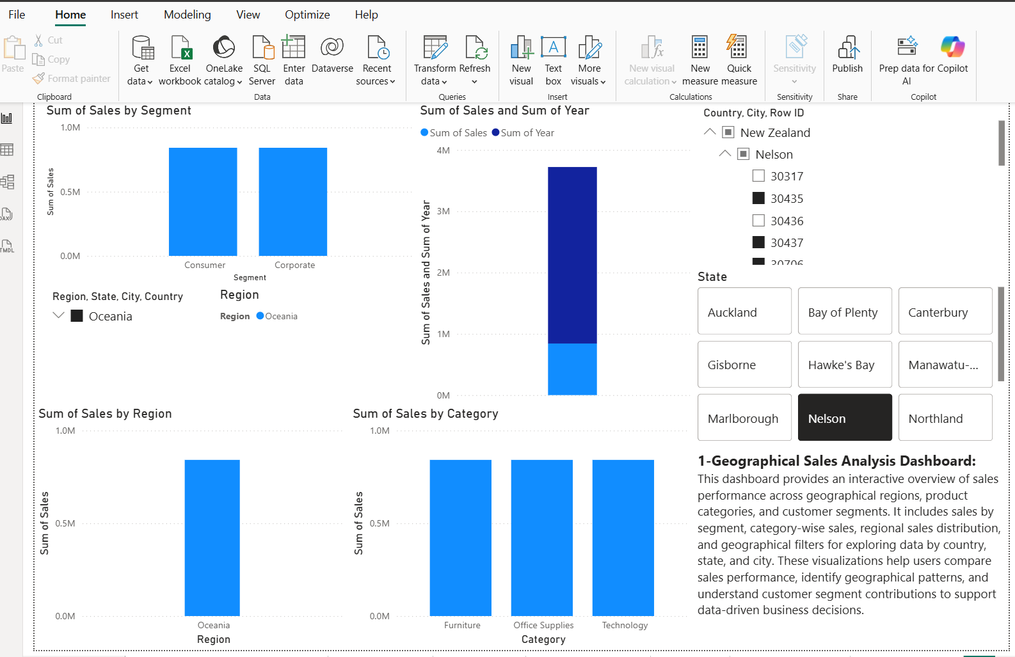Step 3: Open Model View and verify that the existing tables and relationships are available.
Step 4: Confirm that the required fields, including Sales, Profit, Order ID, Order Date, Customer Name, Region, Category, and Segment, are present.
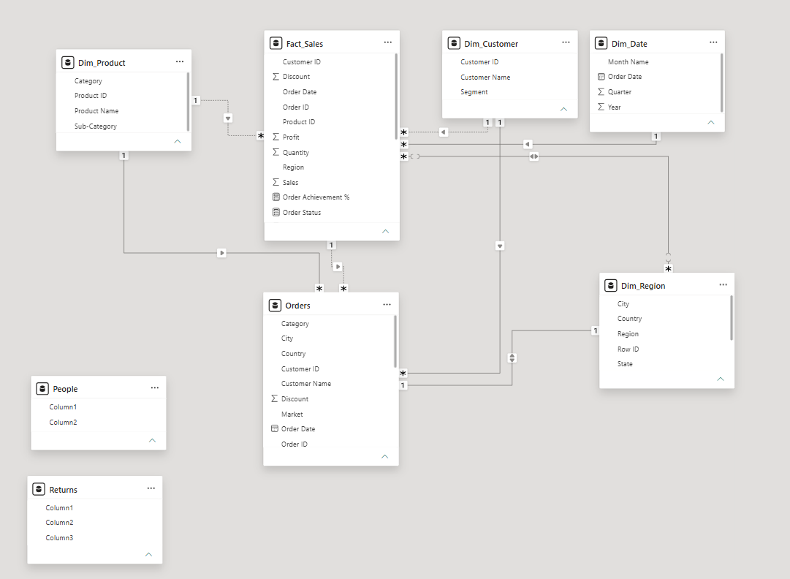
Model View showing tables and relationships
Step 5: Inspect the existing measures and visuals, reusing those that are suitable for the new experiment.

Part B: Create the KPI Measures
Step 6: In the Data pane, check whether Total Sales, Total Profit, and Total Orders measures already exist.
Step 7: Right-click the appropriate table and select New measure for each missing measure.
Step 8: Enter the DAX formulas provided in Section 5.5.
Step 9: Create the Profit Margin % measure using the DIVIDE function.
Step 10: Format Profit Margin % as a percentage and apply suitable numeric or currency formatting to the other measures.

Part C: Build the Executive Dashboard
Step 11: Add a new report page using the + icon and rename it Executive Dashboard.
Step 12: Insert four Card visuals and assign Total Sales, Total Profit, Total Orders, and Profit Margin % to them.
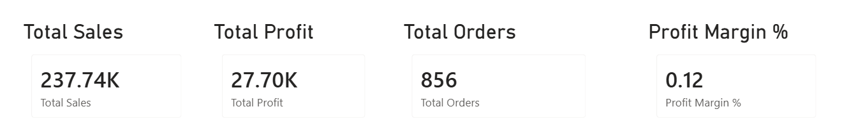
[ Four KPI cards]
Step 13: Insert a bar chart for Sales by Region using Region as the category and Sales as the value.
Step 14: Insert a column chart for Sales by Category using Category and Sales.
Step 15: Insert a line chart for Monthly Sales Trend using Order Date and Sales. Use the month level of the date hierarchy and preserve year information for multi-year data.
Step 16: Insert a bar chart for Top 10 Customers by Sales using Customer Name and Sales.
- Open Filters on this visual.
- Change Customer Name to Top N.
- Enter 10.
- Add Sales to By value.
- Apply the filter.
Step 17: Insert a column chart for Profit by Segment using Segment and Profit.
Step 18: Add three slicers:
- Region.
- Category.
- Year.
Step 19: Arrange the KPI cards at the top and position the charts below them. Place slicers where they are easy to access.
Step 20: Apply appropriate chart titles, labels, formatting, and consistent visual styling.
Step 21: Use Format → Edit interactions to configure the slicers so that they filter the intended visuals.
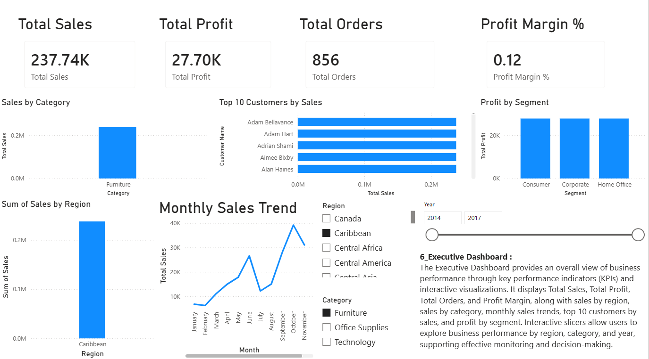
Completed Executive Dashboard page

Part D: Build the Business Scorecard
Step 22: Add a new page and rename it Business Scorecard.
Step 23: Create Sales Target, Profit Target, and Order Target measures using the values defined in Section 5.6.
Step 24: Create Sales Achievement %, Profit Achievement %, and Order Achievement % measures.
Step 25: Create Sales Status, Profit Status, and Order Status measures using the formulas in Section 5.7.
Step 26: Insert a Table visual for Sales and add Total Sales, Sales Target, Sales Achievement %, and Sales Status.
Step 27: Insert another Table visual for Profit and add Total Profit, Profit Target, Profit Achievement %, and Profit Status.
Step 28: Insert a third Table visual for Orders and add Total Orders, Order Target, Order Achievement %, and Order Status.
Step 29: Format sales and profit values appropriately, order counts as whole numbers, and achievement measures as percentages.
Step 30: Apply conditional formatting to the status fields, using green for Achieved, yellow for Partially Achieved, and red for Not Achieved.
Step 31: Arrange the three scorecard visuals clearly so that actual values, targets, percentages, and statuses are easy to compare.
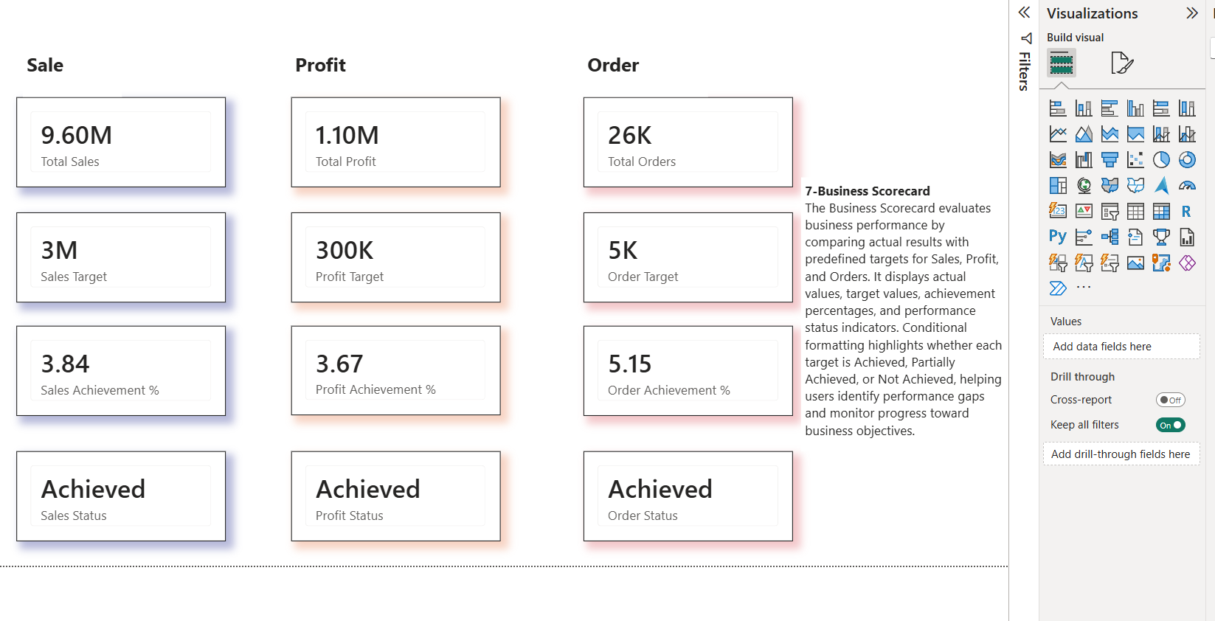
Completed Business Scorecard page

Part E: Test and Validate the Report
Step 32: Select different Region, Category, and Year values and verify that the relevant dashboard visuals update.
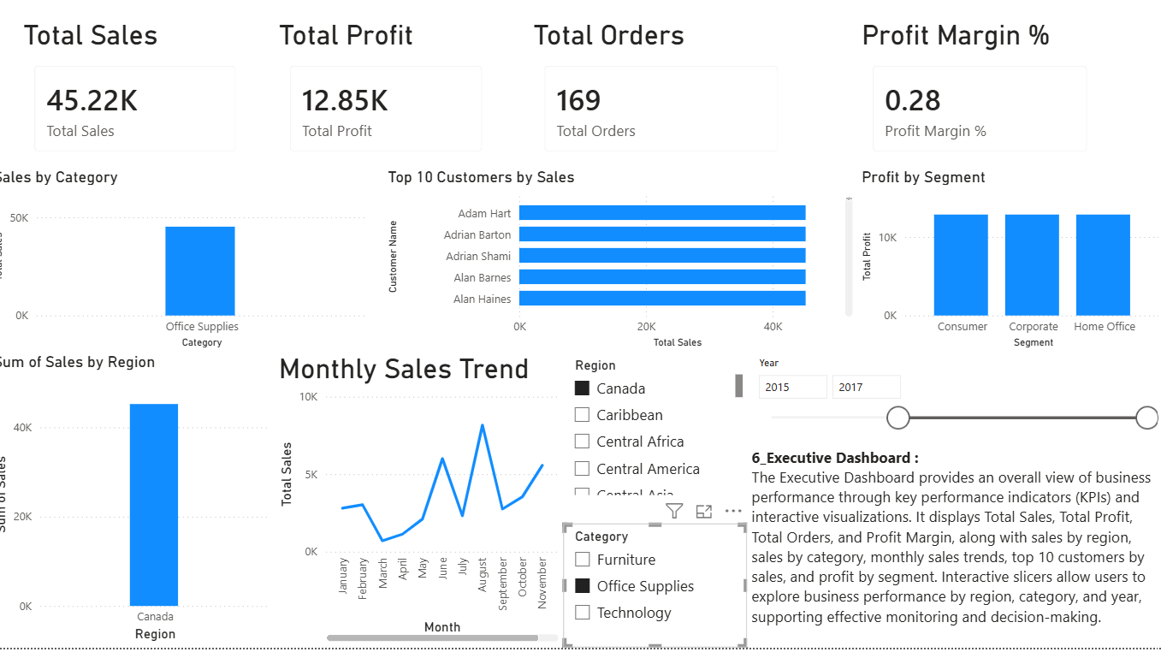
Dashboard with slicer selections applied
Step 33: Clear the slicers and confirm that the overall dashboard view is restored.
Step 34: Verify that Sales Achievement % equals Total Sales divided by Sales Target.
Step 35: Verify that Profit Achievement % equals Total Profit divided by Profit Target.
Step 36: Verify that Order Achievement % equals Total Orders divided by Order Target.
Step 37: Confirm that the status indicators follow the defined achievement thresholds.
Step 38: Save the completed project using Ctrl + S.

Part F: Summary and Interpretation
Step 39: Complete the following table using your actual Power BI observations.
Page | Components | Purpose
Executive Dashboard | Four KPI cards, five charts, Region/Category/Year slicers | Provides a consolidated overview of business performance and interactive data exploration.
Business Scorecard | Actual values, targets, achievement percentages, status indicators, conditional formatting | Evaluates business performance against predefined targets and highlights performance gaps.

7. RESULT
An interactive Executive Dashboard and Business Performance Scorecard were developed in Microsoft Power BI using the existing Global Superstore data model. The Executive Dashboard presents Total Sales, Total Profit, Total Orders, and Profit Margin (%) through KPI cards, along with visualizations for Sales by Region, Sales by Category, Monthly Sales Trend, Top 10 Customers by Sales, and Profit by Segment. Interactive slicers enable users to explore the data by Region, Category, and Year.
The Business Scorecard compares actual Sales, Profit, and Orders with predefined targets. DAX measures calculate achievement percentages and assign performance statuses, and conditional formatting highlights whether each target is achieved, partially achieved, or not achieved. Thus, the experiment demonstrates the implementation of interactive business dashboards, KPI monitoring, target-based performance evaluation, and data-driven reporting using Microsoft Power BI.
8. LEARNING OUTCOMES
- Design an Executive Dashboard using KPI cards and multiple chart types.
- Create and reuse DAX measures in an existing data model.
- Calculate Total Sales, Total Profit, Total Orders, and Profit Margin.
- Implement interactive slicers and configure visual interactions.
- Develop a Business Scorecard for comparing actual results with predefined targets.
- Calculate achievement percentages and create status indicators.
- Apply conditional formatting to improve the visual interpretation of performance.
- Understand how Power BI dashboards and scorecards support business performance monitoring and informed decision-making.

